Final Project Report — Programming Fundamentals

University Name: [FAST NUCES Karachi Campus]
Department: Department of Computer Science

Course: Programming Fundamentals

Project Title: Budget Tracker

Submitted By: [Mahad Saqib] (Roll No. 25K-0509) [Arsalan Ahmed] (Roll No. 25K-0754)
Submitted To: [Mr. Sheeraz Iqbal]
Semester: Fall 2025
Date: [21st November, 2025]

ABSTRACT:
The Budget Tracker is a command-line application developed in C language to help individuals record and monitor their income and expenses. The system is designed in such a way to allow users to save their details such as their earnings, sources of income, and where they spend money, etc. The system will generate a simple report summarizing spending patterns, which will help users manage their finances effectively.
1) Introduction:
Manually keeping records of all your transactions, is time consuming and resourceful. It is also not efficient for the person and keeping it organized is a big hassle. Our project, ”Budget Tracker” helps in dealing with all of these problems, in an efficient and cost-effective way, keeping the data stored locally, and keeping it organized. The project is made using the basic concepts of programming in C, and some professional coding techniques of structures (STRUCTS), file-handling (FILING) and the use of functions for a neat and optimized code.
2) Objectives:
- Store the users basic information (income and source).
- Record the expenses with date, amount, and category.
- Notify the user when spendings cross a set budget limit.
- Generate a report summarizing income vs. expenses.
- Data persistence through file handling (saving and loading records).
- CLI-based user-friendly menus for interaction.
- Categorized Expense Analysis, showing how much is spent in categories like Food, Transport, Utilities, etc.
- Search Functionality by find expenses by date or category
- Highlight Largest And Smallest Expense and identifying which category or transaction consumed the most budget.
- Track taxes.

3) System Design:
a) System Overview
Flow of the program:
Start, Display Menu, Input User’s Budget Limit, Input User’s every transaction, Perform Calculations, and save transaction, Exit.
b) Algorithm
1) START.
2) Input BudgetLimit.
3) Show Menu of options.
4) Input Menu Option choice.
5) Select the operation (1 to 9 in our program).
6) Input relevant data (e.g. Transaction type, D.o.T., description and amount spent/gained, for ADD Transaction as shown in the the code).
7) Perform the operations of the chosen function.
8) REPEAT from (3) Until Menu choice becomes 9 (SAVE AND EXIT function).
9) SAVE the data in text file, and EXIT the program.
10) STOP.
c) Input & Output
Input: User Initial Budget Limit, Transactions (Income/Expense), Transaction Type, Description and Date of transaction.
Output: View and Save All Transactions, show Category-wise Analysis, show Basic Financial Summary (Income vs. Expense), search Transaction by Date, search Transaction by Category, search Largest & smallest Expense and show Summary & Tax Calculation
4) Implementation:
Language: C
Compiler/IDE: Code: Blocks / Dev C++ and VS Code / GCC Compiler (Made sure to make it able to work in popular IDEs)

5) Key Features:
- Record the expenses with date, amount, and category.
- Notify the user when spendings cross a set budget limit.
- Generate a report summarizing income vs. expenses.
- Search Functionality by finding expenses by date or category
- Highlight Largest And Smallest Expense and identify which category or transaction has consumed the most budget.
- Track taxes.
6) Code Snippet:
void addTransaction()
{
if (count >= MAX_TRANSACTIONS)
{
printf(RED "\nTransaction list is full!\n" RESET);
return;
}

struct Transaction t;

printf("\nEnter type (Income/Expense): ");
fgets(t.type, sizeof(t.type), stdin);
trimNewline(t.type);

printf("Transaction Categories\nFor Income (e.g:Salary, Bonus, Profits)\nFor Expense(e.g: Food, Rent, Transport, Utilities): ");
fgets(t.category, sizeof(t.category), stdin);
trimNewline(t.category);

printf("Enter description: ");
fgets(t.description, sizeof(t.description), stdin);
trimNewline(t.description);

printf("Enter amount: ");
if (scanf("%f", &t.amount) != 1) {
printf(RED "Invalid amount entered. Transaction cancelled.\n" RESET);
clearInputBuffer();
return;
}
clearInputBuffer();

printf("Enter date (DD/MM/YYYY): ");
fgets(t.date, sizeof(t.date), stdin);
trimNewline(t.date);

transactions[count++] = t;

processingAnimation(20);

if (strcasecmp(t.type, "Income") == 0)
{
currentBalance += t.amount;
printf(GREEN "\nTransaction added successfully! Current Balance: %.2f\n" RESET, currentBalance);
}
else if (strcasecmp(t.type, "Expense") == 0)
{
currentBalance -= t.amount;
printf(RED "\nTransaction added successfully! Current Balance: %.2f\n" RESET, currentBalance);
}
else
{
printf(GREEN "\nTransaction added successfully!\n" RESET);
}

float totalExpense = getTotalExpense();
if (totalExpense > budgetLimit)
{
printf(RED "\nALERT!: You have exceeded your overall budget limit of %.2f!\n" RESET, budgetLimit);
}
}

Sample Output/ Program Output:
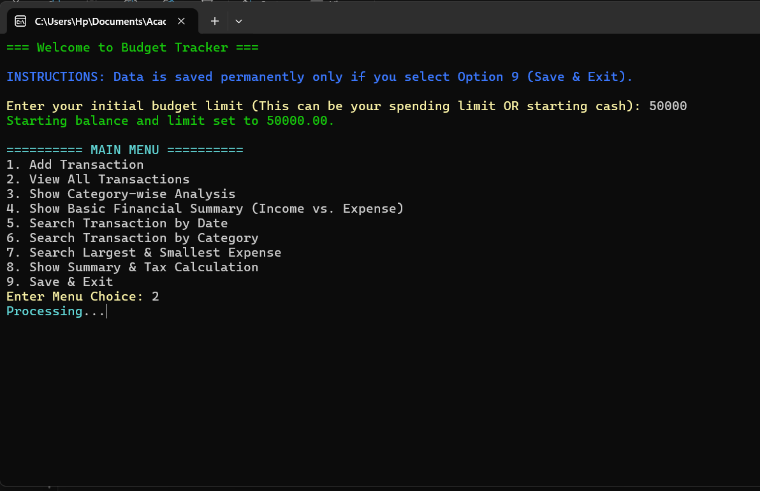
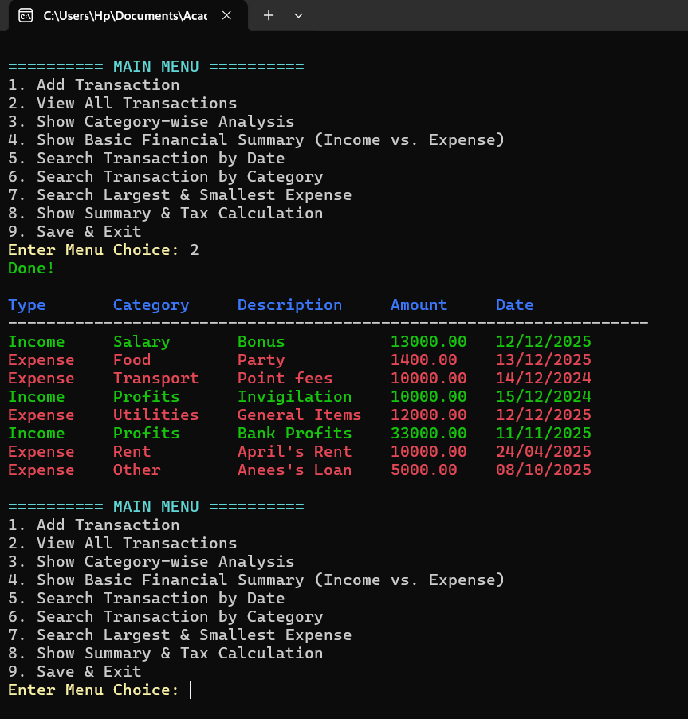

5) Testing And Results
The program runs as expected, storing the relevant data as the program runs, providing the necessary calculation as described in the options for the menu. From the sample output, the program is able to recall previously stored data. The Optional taxing and highest and smallest expenses checker is also added. There is a delay function with processing animation, we added this as the program is fairly fast and it could be confusing if all the calculations come up suddenly on screen.
6. Conclusion, Limitations &amp; References
Conclusion:
The Budget Tracker, for the everyday person, is an important project as it a useful program and we learnt C basics and professional using C language has given us experience in programing. The program is by far no mean perfect, however it is significant and useful in the daily lives of many people. Personally, we would still like to develop on this further and keep using it.
Limitations:
- Deletion of record, (We deemed it unnecessary since the use case was for 1 go calculations and sorting).
- Graphical User Interface, (The program can be made more appealing if it had a GUI implemented, however GUI in C language is a problem on its own, leading to a much more complex code.)
Future Enhancements
- The GUI implementation. (Graphs and Pie Charts, an appealing background, etc.).
- Direct MS EXCEL spreadsheet creation through filing (Currently filing is done on notepad).
- The program is for everyday Budget Tracking, for the everyday person. An industrial level implementation would require severe reworking of the code; however, the concept remains the same.
References
- For Basics of C: https://www.geeksforgeeks.org/c-programming-language/
- Bro Code For C: https://www.youtube.com/watch?v=xND0t1pr3KY
- For inspiration and referencing exsisting systems https://github.com/

